

# 

### Semester Two Examination, 2017

### Question/Answer booklet

# MATHEMATICS

If required by your examination administrator, please place your student identification label in this box

**APPLICATIONS**

**UNITS 3 AND 4**

## Section One:

## Calculator-free

|  |  |  |  |  |  |  |  |  |  |  |
| --- | --- | --- | --- | --- | --- | --- | --- | --- | --- | --- |
| Student Number: In figures |  |  |  |  |  |  |  |  |  |  |

**Maths Teacher**

**Your name**

## Time allowed for this section

Reading time before commencing work: five minutes

Working time: fifty minutes

## Materials required/recommended for this section

***To be provided by the supervisor***

This Question/Answer booklet

Formula sheet

***To be provided by the candidate***

Standard items: pens (blue/black preferred), pencils (including coloured), sharpener, correction fluid/tape, eraser, ruler, highlighters

Special items: nil

## Important note to candidates

No other items may be taken into the examination room. It is **your** responsibility to ensure that you do not have any unauthorised material. If you have any unauthorised material with you, hand it to the supervisor **before** reading any further.

## Structure of this paper

|  |  |  |  |  |  |
| --- | --- | --- | --- | --- | --- |
| Section | Number of questions available | Number of questions to be answered | Working  time (minutes) | Marks available | Percentage of examination |
| Section One:  Calculator-free | 7 | 7 | 50 | 52 | 35 |
| Section Two:  Calculator-assumed | 12 | 12 | 100 | 98 | 65 |
|  | | |  | **Total** | 100 |

|  |  |  |
| --- | --- | --- |
| Markers use only | | |
| Question | Maximum | Mark |
| 1 | 6 |  |
| 2 | 5 |  |
| 3 | 7 |  |
| 4 | 8 |  |
| 5 | 8 |  |
| 6 | 10 |  |
| 7 | 8 |  |
| S1 Total | 52 |  |
| S1 Wt (×0.6731) | 35% |  |
| S2 Wt | 65% |  |
| Total | 100% |  |

## Instructions to candidates

1. The rules for the conduct of examinations are detailed in the school handbook. Sitting this examination implies that you agree to abide by these rules.

2. Write your answers in this Question/Answer booklet.

3. You must be careful to confine your response to the specific question asked and to follow any instructions that are specified to a particular question.

4. Additional working space pages at the end of this Question/Answer booklet are for planning or continuing an answer. If you use these pages, indicate at the original answer, the page number it is planned/continued on and write the question number being planned/continued on the additional working space page.

5. Show all your working clearly. Your working should be in sufficient detail to allow your answers to be checked readily and for marks to be awarded for reasoning. Incorrect answers given without supporting reasoning cannot be allocated any marks. For any question or part question worth more than two marks, valid working or justification is required to receive full marks. If you repeat any question, ensure that you cancel the answer you do not wish to have marked.

6. It is recommended that you do not use pencil, except in diagrams.

7. The Formula sheet is not to be handed in with your Question/Answer booklet.

Section One: Calculator-free 35% (52 Marks)

This section has**seven (****7)** questions. Answer **all** questions. Write your answers in the spaces provided.

Working time: 50 minutes.

Question 1 (6 marks)

The network shows a system of pipes with the maximum capacity for each pipe, in litres per second, shown on the edges.

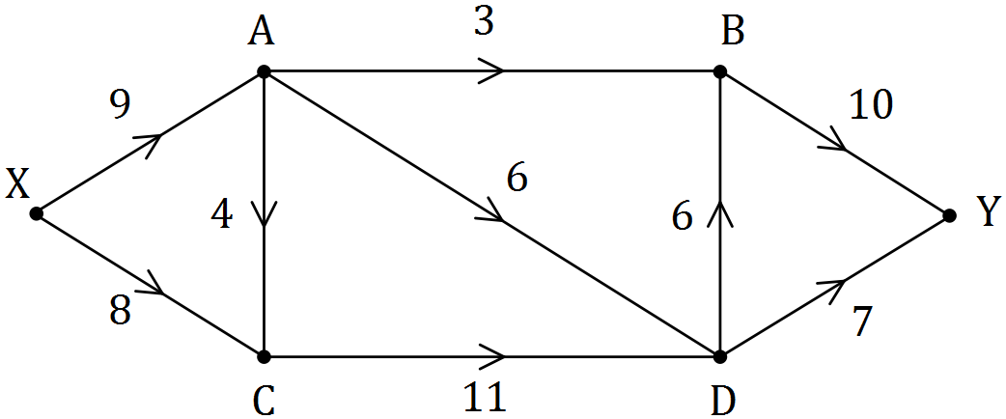

(a) Cut $M$ passes through edges $XA$, $AC$ and $CD$, and cut $N$ passes through edges $BY$ and $DY$. Show these cuts on the network and state their capacities. (2 marks)

(b) Determine the maximum flow through the system from $X$ to $Y$ by listing each path used and the flow along each path. (3 marks)

(c) Show cut $Z$ on the network that has capacity equal to the maximum flow. (1 mark)

Question 2 (5 marks)

Cabling between ten distribution boards in a factory is to be upgraded to ensure the supply of electricity between all boards in an emergency. The upgrade costs between adjacent boards, in thousands of dollars, are shown on the edges in the weighted graph.

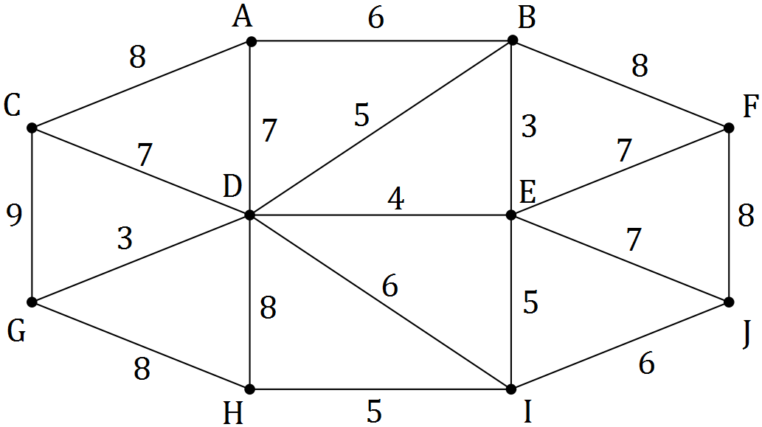

(a) Determine the minimum spanning tree for the graph, clearly showing it on the graph.

(3 marks)

(b) Calculate the cost of upgrading the cabling that forms the minimum spanning tree.

(2 marks)

Question 3 (7 marks)

Five people, $A, B, C, D$ and $E$ are to be allocated to five tasks, $1, 2, 3, 4$ and $5$. The bipartite graph below shows the tasks that each of the five people can carry out.

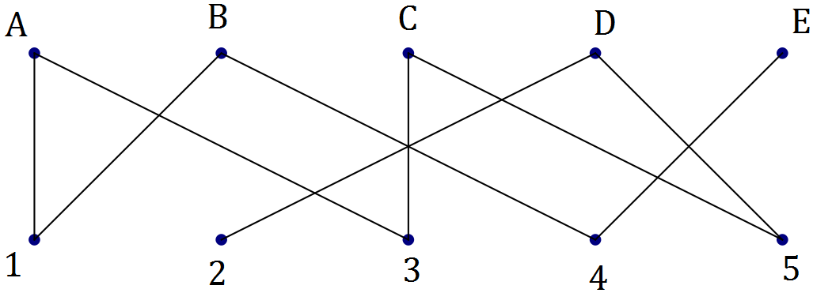

(a) Explain why the graph is connected. (1 mark)

(b) Explain why the graph is not a complete bipartite graph, and state the number of edges the graph would have if it was a complete bipartite graph. (2 marks)

(c) If person $A$ is assigned to task $1$, explain why a complete matching of people to tasks is not possible. (2 marks)

(d) Determine a complete matching of people to tasks. (2 marks)

Question 4 (8 marks)

(a) A sequence has the recursive definition $T_{n+1}=0.5T_{n}-10, T_{1}=64$. Determine the value of the first term of the sequence that is less than $0$. (3 marks)

(b) Consider the arithmetic sequence $11, 14, 17, 20, …$.

(i) Determine the st term of the sequence. (3 marks)

(ii) Determine the value of $n$ if $371$ is the th term of the sequence. (2 marks)

Question 5 (8 marks)

The digraph below represents a system of one-way streets that enable travel between five locations $A, B, C, D$ and $E$.

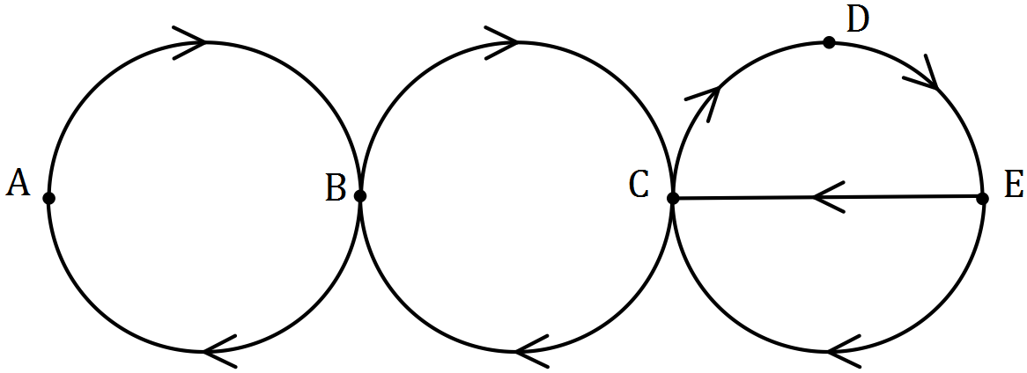

(a) Complete the adjacency matrix below for the digraph. (2 marks)

|  |  |  |  |  |  |
| --- | --- | --- | --- | --- | --- |
|  | $$A$$ | $$B$$ | $$C$$ | $$D$$ | $$E$$ |
| $$A$$ |  |  |  |  |  |
| $$B$$ |  |  |  |  |  |
| $$C$$ |  |  |  |  |  |
| $$D$$ |  |  |  |  |  |
| $$E$$ |  |  |  |  |  |

(b) State whether a closed walk of length 5 can start from vertex $B$. If yes, list the vertices on the walk. If no, explain why not. (2 marks)

(c) The graph is semi-Hamiltonian. Clearly explain what this means. (2 marks)

(d) List, in order, a set of vertices that must be visited to create a trail that includes every edge of the graph just once. (2 marks)

Question 6 (10 marks)

The following table shows the scores of four people, Eli, Fa, Greg and Hari after taking four tests in aviation (A), business (B), commerce (C) and design (D).

|  |  |  |  |  |
| --- | --- | --- | --- | --- |
|  | Eli | Fa | Greg | Hari |
| A | $$12$$ | $$14$$ | $$10$$ | $$12$$ |
| B | $$15$$ | $$15$$ | $$14$$ | $$11$$ |
| C | $$10$$ | $$11$$ | $$14$$ | $$10$$ |
| D | $$11$$ | $$10$$ | $$12$$ | $$9$$ |

Each of the four people are to be assigned to one of the four tests so that the total score is maximised. No-one can be assigned to more than one test.

(a) Explain why the Hungarian algorithm may be used to find the optimal assignment if each number in the table, $n$, is replaced by $15-n$. (2 marks)

(b) Form a new table by replacing each number in the original table, $n$, with $15-n$. (1 mark)

|  |  |  |  |  |
| --- | --- | --- | --- | --- |
|  | Eli | Fa | Greg | Hari |
| A |  |  |  |  |
| B |  |  |  |  |
| C |  |  |  |  |
| D |  |  |  |  |

(c) Show that, by reducing **rows first** and then columns, the resulting table is as shown at the top of the next page. (2 marks)

|  |  |  |  |  |
| --- | --- | --- | --- | --- |
|  | Eli | Fa | Greg | Hari |
| A | $$2$$ | $$0$$ | $$4$$ | $$0$$ |
| B | $$0$$ | $$0$$ | $$1$$ | $$2$$ |
| C | $$4$$ | $$3$$ | $$0$$ | $$2$$ |
| D | $$1$$ | $$2$$ | $$0$$ | $$1$$ |

(d) Show that the zeros in the table above can be covered with two horizontal lines and one vertical line. Hence use the Hungarian algorithm to reduce the table to a form where four lines are required to cover all zeros. (2 marks)

(e) Determine how each of the people should be assigned to the four tests to maximise the total score, and state what this maximum score is. (3 marks)

Question 7 (8 marks)

(a) Redraw the following graph to clearly show that it is planar. (2 marks)

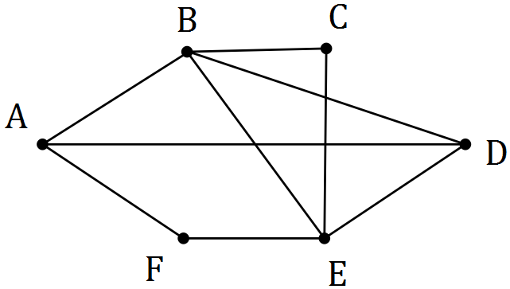

(b) Verify Euler's formula for the graph below. (3 marks)

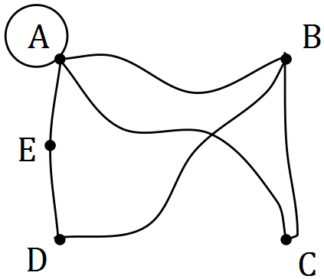

(c) Let $K_{n}$ be a complete graph with $n$ vertices.

(i) Draw the graph $K_{5}$. (1 mark)

(ii) Determine the number of edges in a minimum spanning tree for graph $K_{4}$. (1 mark)

(iii) State, in terms of $n$, the number of edges in a minimum spanning tree for graph $K_{n}$.

(1 mark)

Additional working space

Question number: _________

© 2017 WA Exam Papers. Kennedy Baptist College has a non-exclusive licence to copy and communicate this document for non-commercial, educational use within the school. No other copying, communication or use is permitted without the express written permission of WA Exam Papers. SN245-106-1.